**------------------------------RDT-----------------------------**

1.0: Reliable transfer, Reliable channel

2.0: channel with bit errors

Question: recover from errors

Solution: 1.error detection. 2. Feedback(ACK, NAK)

2.1: sender, handles grabled ACK/NAK

Solution: sequence number

2.2: NAK-free

3.0: channels with errors and loss

Solution: time

**------------------------------TCP-----------------------------**

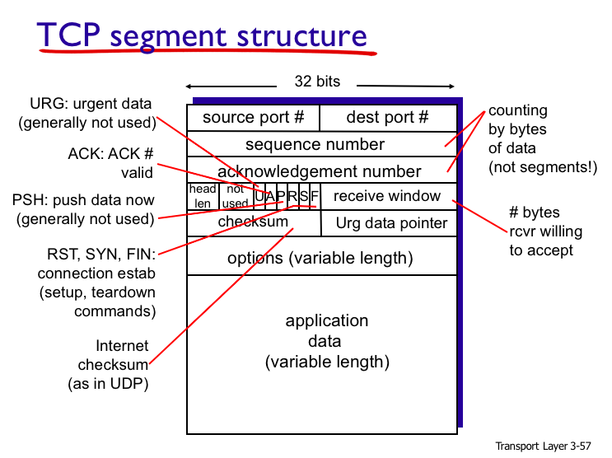

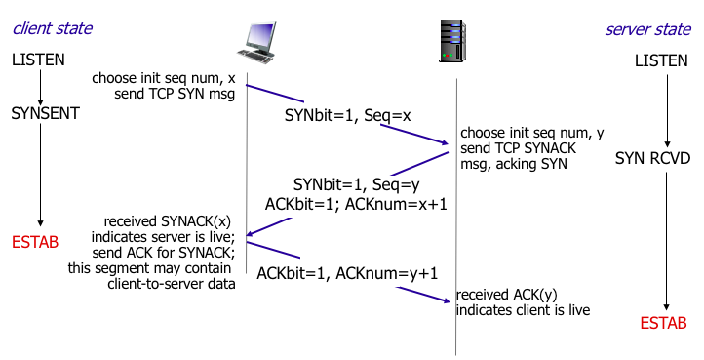**TCP Congestion Control**:  
**Slow Start**: double cwnd every RTT

**Congestion Avoidance**:

cwnd += (MSS/cwnd)*MSS upon every incoming non-duplicate ACK

**Time out**: ssthresh = cwnd/2, cwnd=1

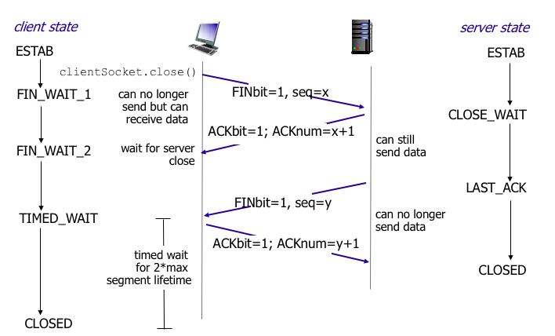

**Fast retransmit / fast recovery**:

ssthresh = cwnd/2

cwnd = ssthresh + 3MSS

retransmit the lost packet

increase cwnd by 1 MSS upon every duplicate ACK

**------------------------------IPv4 and IPv6-----------------------------**

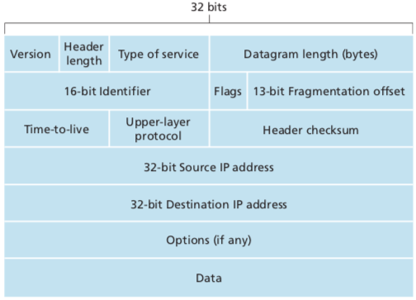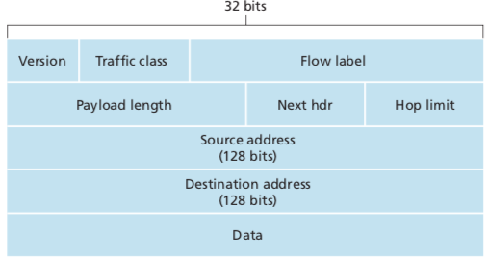

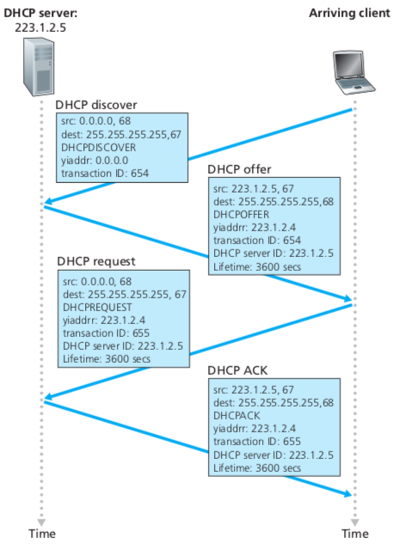

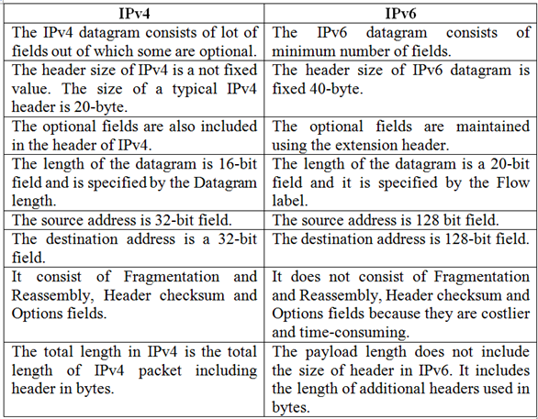

**------------------------------Link-state vs. distance-vector------------------------------**

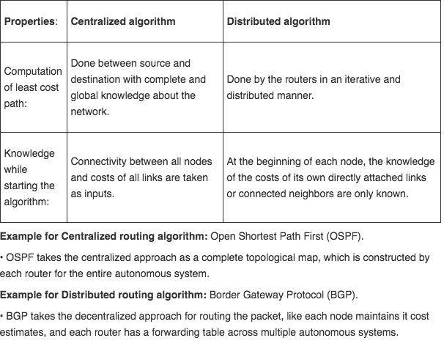

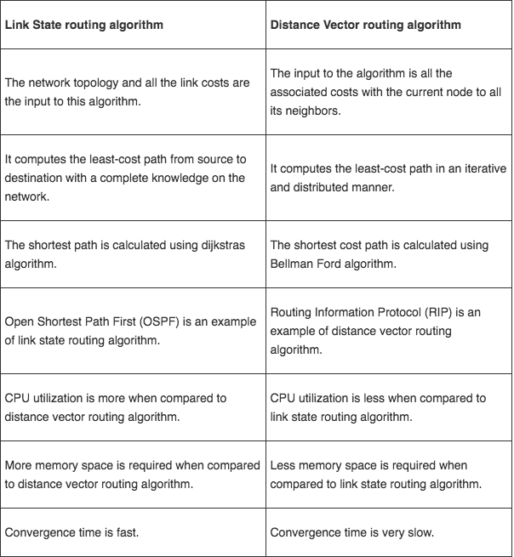

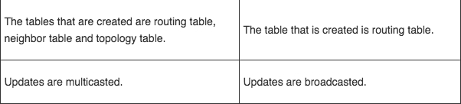

**--------------Link-layer---------**

**Services**:

Framing, Link access (MAC), Reliable delivery, Error detection and correction

**Broadcast channel:**

1.One node transfer at full rate 2. Fairness 3. Decentralized

4. Simple and efficient

**Category:**

Channel partitioning, random access, taking turns

**------------------------------CSMA/CD ------------------------------**

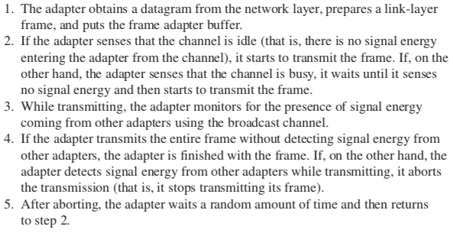

**-------------------------Router vs. Switch-------------------------**

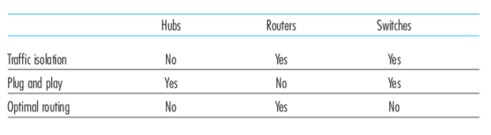

**-----------------------Switch self-learning-----------------------**

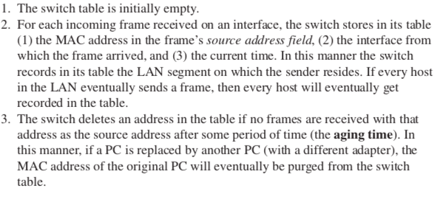

**------------------------------daily life on web------------------------------**

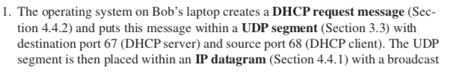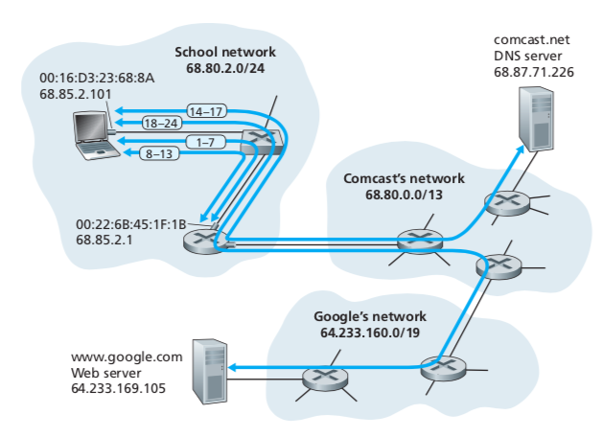

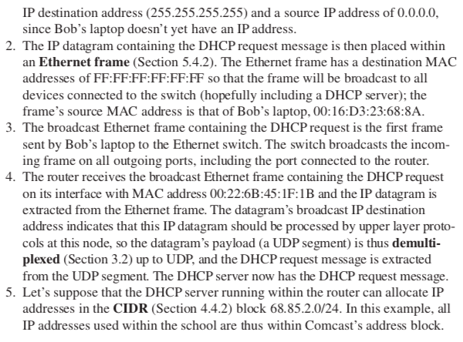

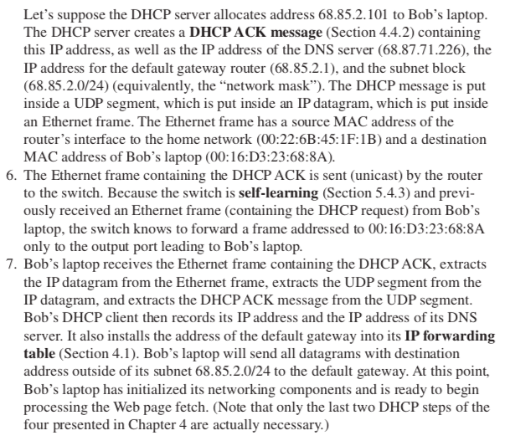

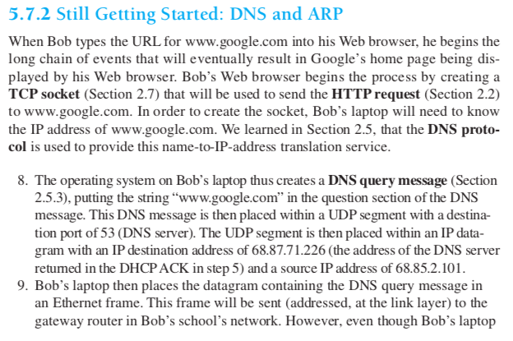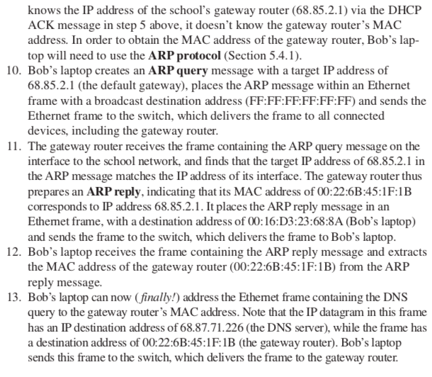

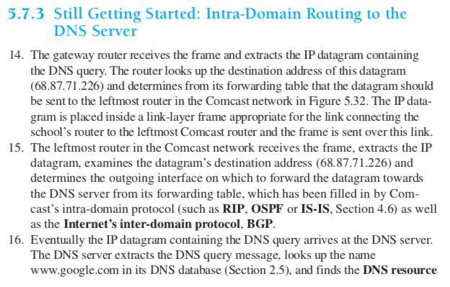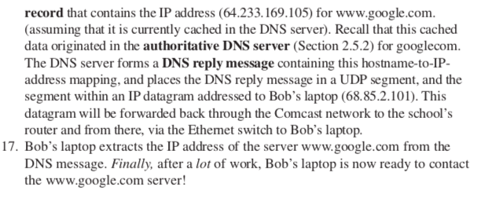

**CDMA:**

Channel partitioning

Z = di * cm

Di=sum(Zi,m*cm)/M

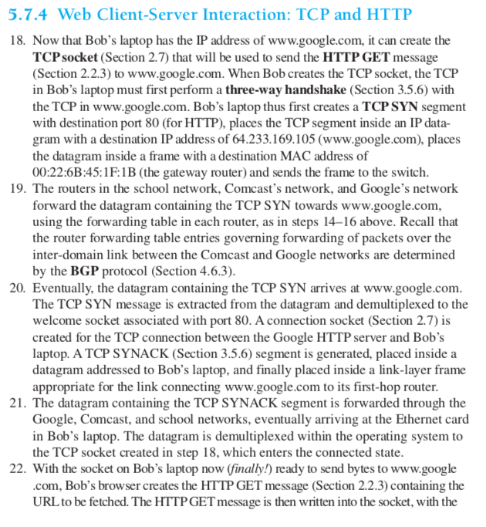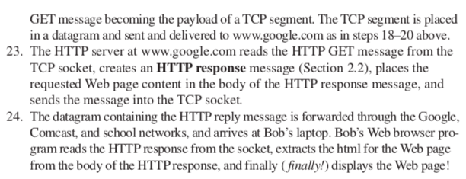

**------------------------------CSMA/CA------------------------------**

**CA over CD:**

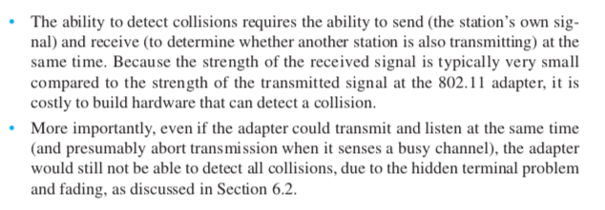

**Details:**

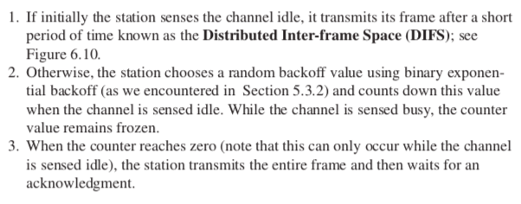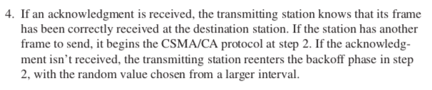

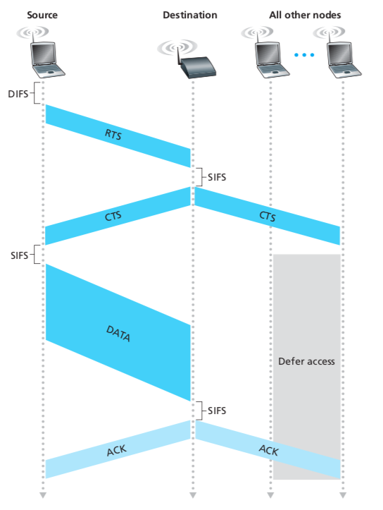

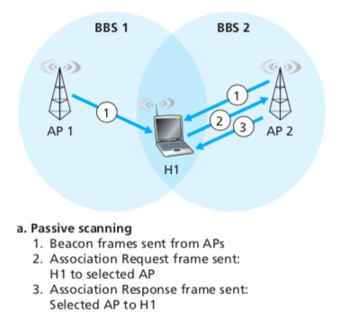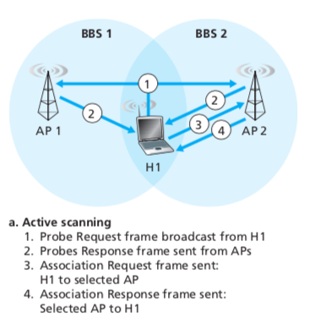

**802.11 frame**

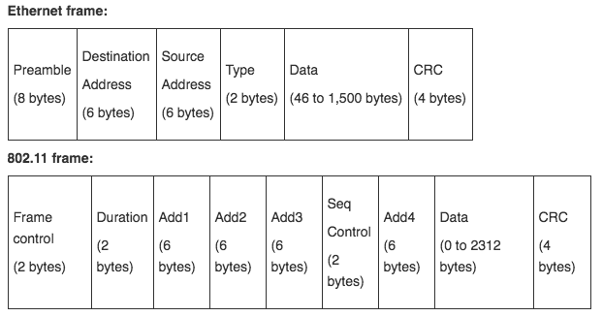

**Indirect routing:** 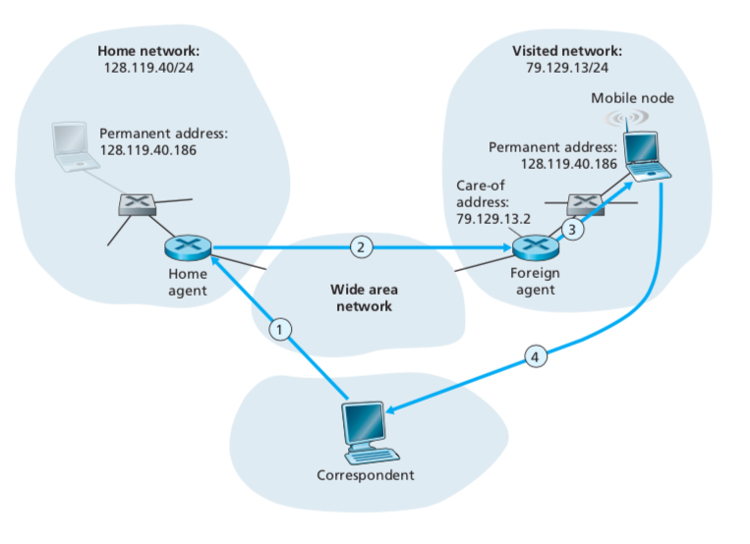3G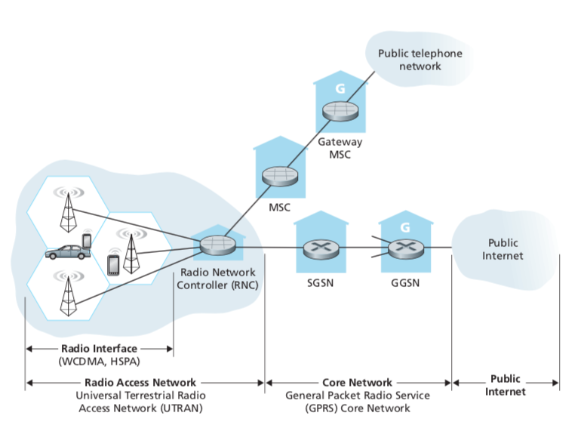

Direct Routing: 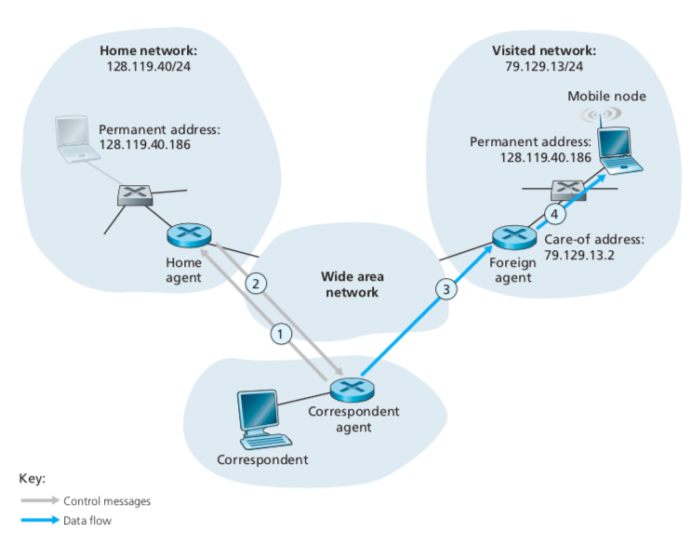

Mobile IP registration: 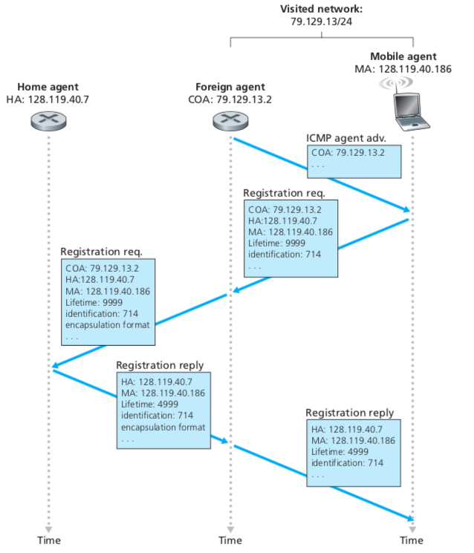

Handoff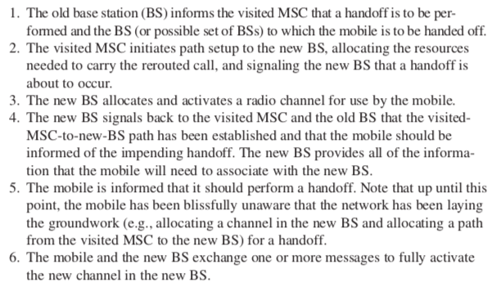

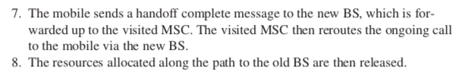

**Network security**

**Confidentiality**: only sender, intended receiver should “understand” message contents

**Authentication**: sender, receiver want to confirm identity of each other

**Message integrity**: sender, receiver want to ensure message not altered without detection

**Access and availability**: service must be accessible and available to users

**Authentication**:

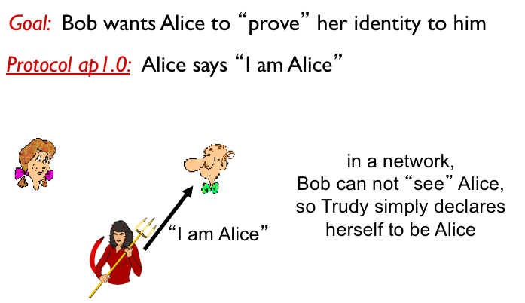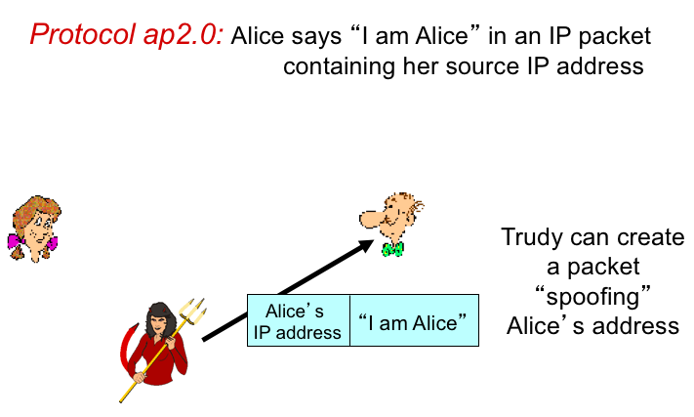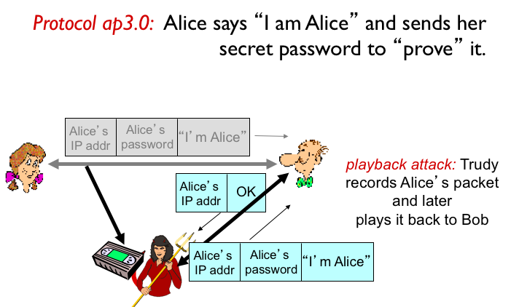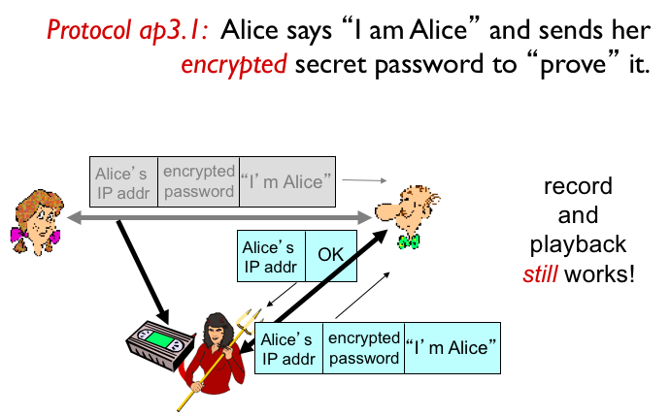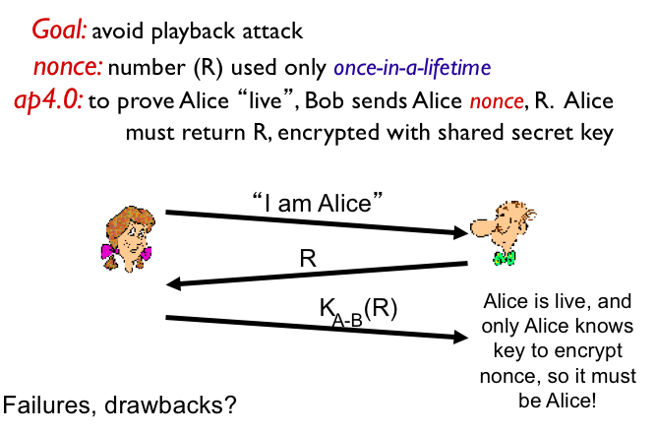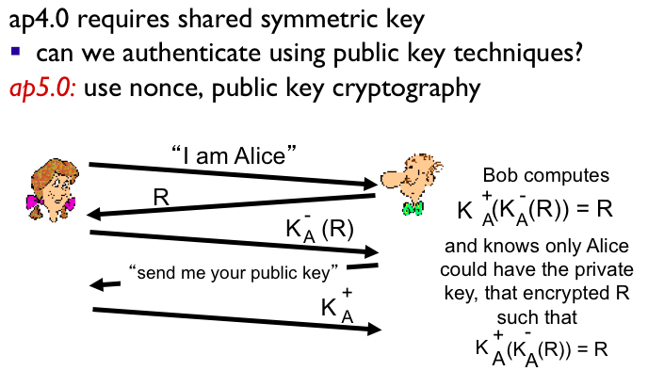

**Digital signature**: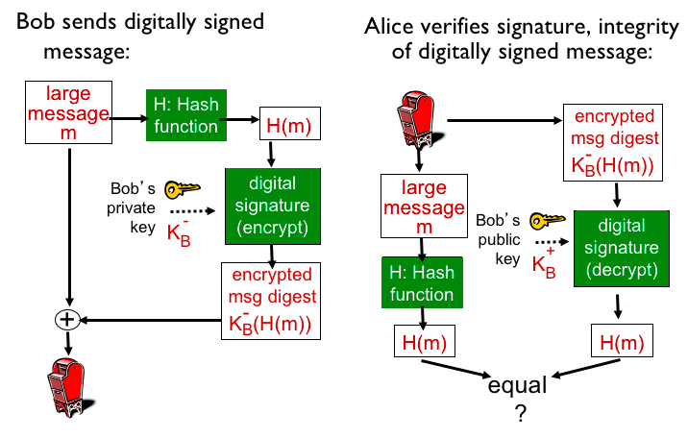

**Certification authority**

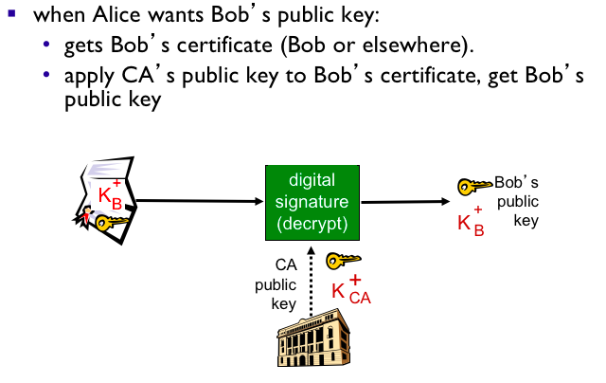

**-------------VPN--------------**

**SSL**

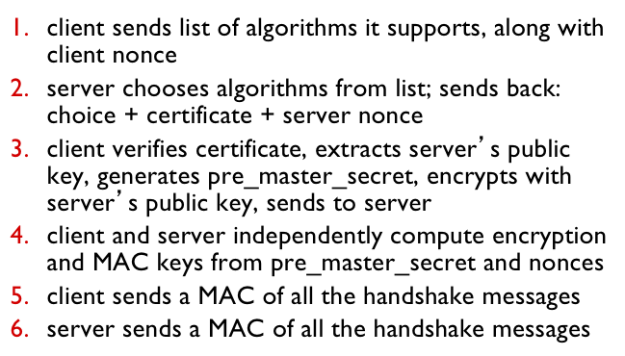

**Why two random nonces?**

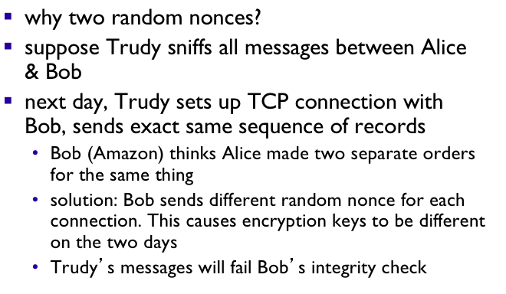

**Real SSL:**

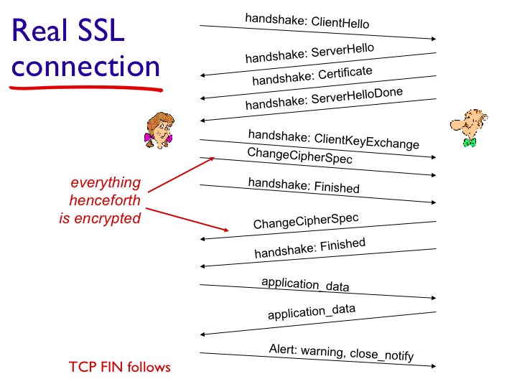

**Example security association:**

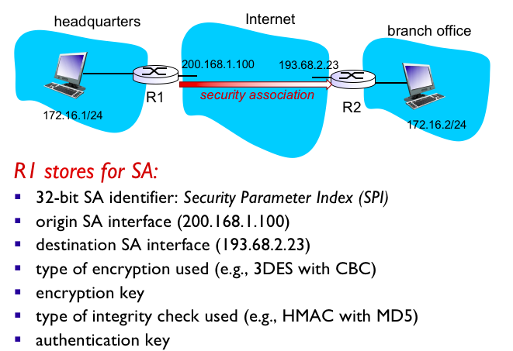

**IPsec Services:**

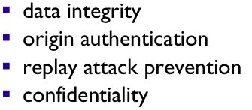

**Security Association database:**

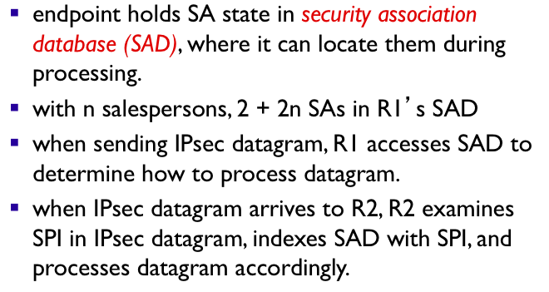

**IPsec datagram:**

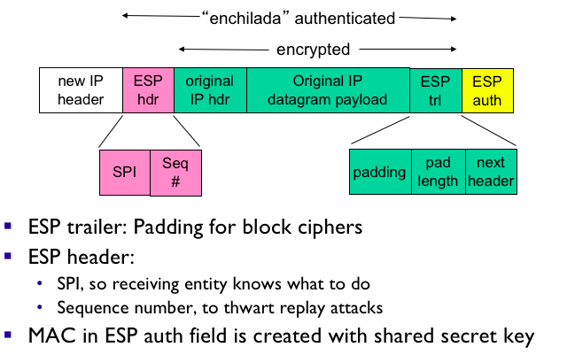

**R1: Convert original datagram to IPsec datagram**

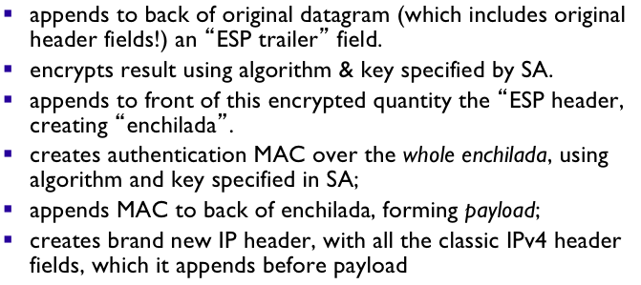

**IPsec seq#:**

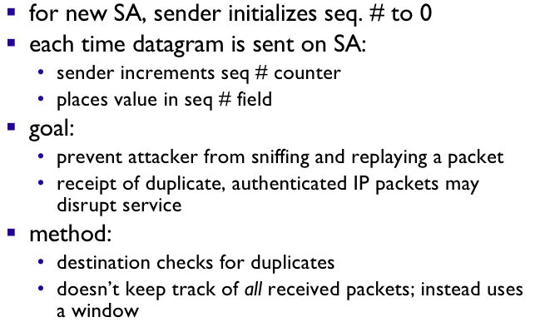

**Firewalls**

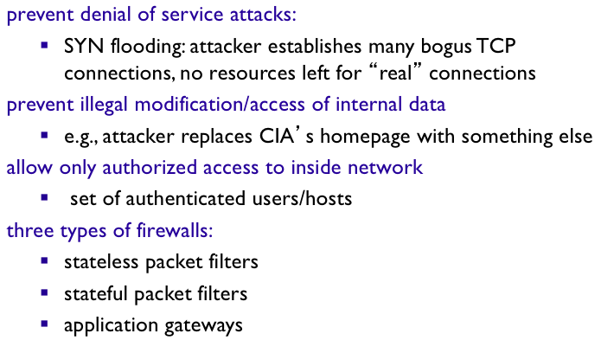

**Limitations**

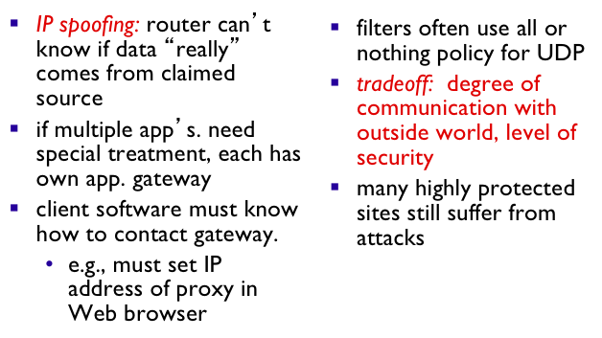

**Intrusion detection systems**

